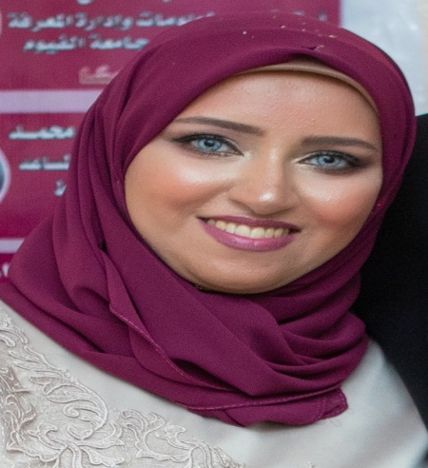
Zienab Mohammed Hesham Salem Hassen

Personal Profile

Phone: 01098139643
Address: Helaly St. Altawfeeq Tower – Block No. (5) ,Apartment No.( 1 )
Email : zienab.hesham@yahoo.com - zeinab.hesham@aun.edu.eg
0882058453 faculty Fax No:
Languages: English , Arabic
Date of Birth: 3-9-1990
Workplace: Faculty of Arts – Asyut University

Career Objective

Academic qualifications

- BA majoring in : Libraries , documentation and information I June 2011 with " Very good grade".
- Pre master's study in Libraries , documentation and information majoring in information Technology from the Faculty of Arts - Fayoum University in June , 2012 with " Very Good grade " .
- MA Degree in Arts – Department of Libraries , documentation and information - Information Technology Division with " excellent grade"; being recommended for mutual publication among Egyptian Universities in June, 2016 .
- PhD . Degree in Arts – Department of Libraries , documentation and information - Information Technology Division with " great Honor Grade" in November , 2020 .

Achievements

Awards:
- Asyut University Award for the best Academic Thesis ( Master's Degree) majoring in social and humanitarian Sciences in January -2021 .
Academic Experience :
- A demonstrator at The Department of Libraries , documentation and information – Faculty of Arts – Asyut University- from 2013 to 2016.
- Assistant Teacher at The Department of Libraries , documentation and information – Faculty of Arts – Asyut University- from 2016 to 2020.
- Teacher at The Department of Libraries , documentation and information – Faculty of Arts – Asyut University- since 2020 up till now.

Training Courses :
- A certificate of (logical thinking rules ) from " with mind we start " EST. Asyut Governorate Branch in 2018
- A certificate of Basic English Skills from The English Language Center – Asyut University in 2020 .
- A certificate of TOT "Trainer of Trainers" from E youth EST. in 2020
Workshops :
- "Mechanisms of Academic publication on behalf of the Teaching Staff in the international periodicals" during the period on April 2nd through April 3rd – Faculty of Arts – Asyut University .
- "Management and classification of Citations and Academic references by using Mendeley System" in November , 2018 – Asyut University.

Published Academic researches :
- The presidential libraries and museums at " the United States of America" as a model – May 2016 – the Academic Magazine of the Faculty of Arts – Asyut university .

- A proposed design of constructing an Egyptian presidential library and Museum –- A 64 October – 2017 - the Academic Magazine of the Faculty of Arts – Asyut University .

- The reality of the applications of Robotic technology in some foreign countries: An analytic – descriptive study –A 73 January in 2020 - the Academic Magazine of the Faculty of Arts – Asyut University.

Education

Grade achieved: Professor at The Department of Libraries , documentation and information – Faculty of Arts – Asyut University
Skills

Interpersonal:
leadership
teamwork
motivation ,
responsibility

Technical:
Html
Html5
Css3
Xml
Xslt
Microsoft office

